Github - <https://github.com/ladyCoder18/ComputerVision/tree/main/Assignment%203>

Same Video from the previous assignment is used here

1. Matching Images   
     
   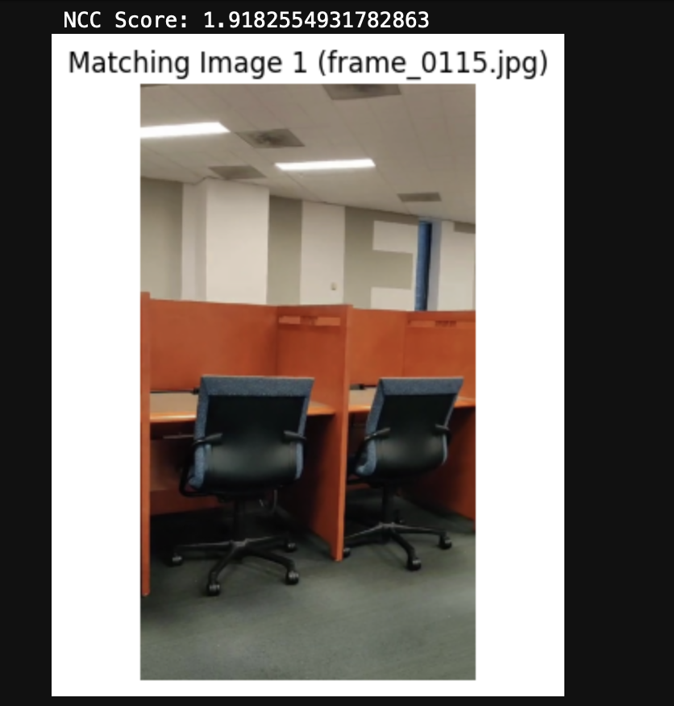

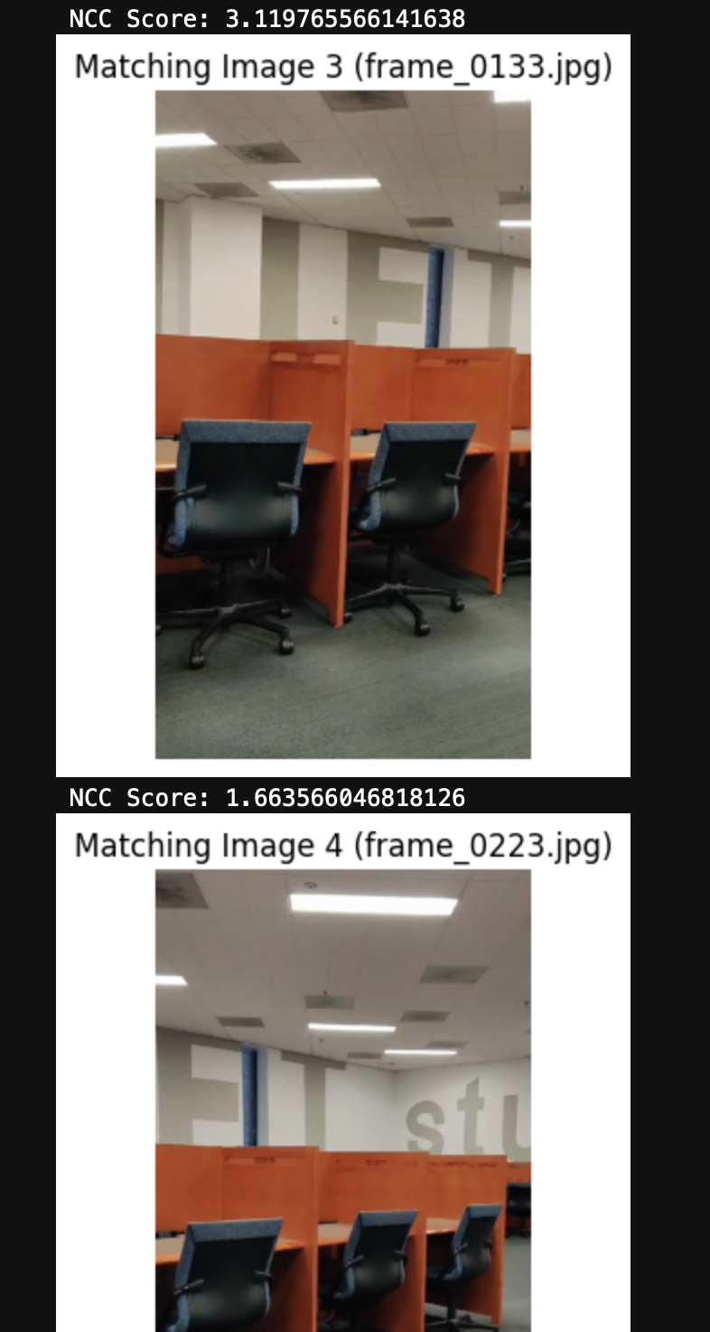

1. a.
2. Computation of distance D using disparity based depth estimation in stereo-vision theory.

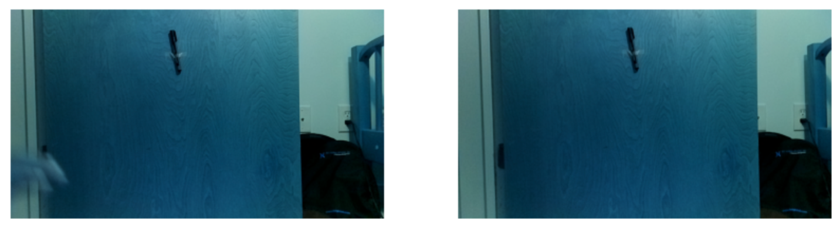

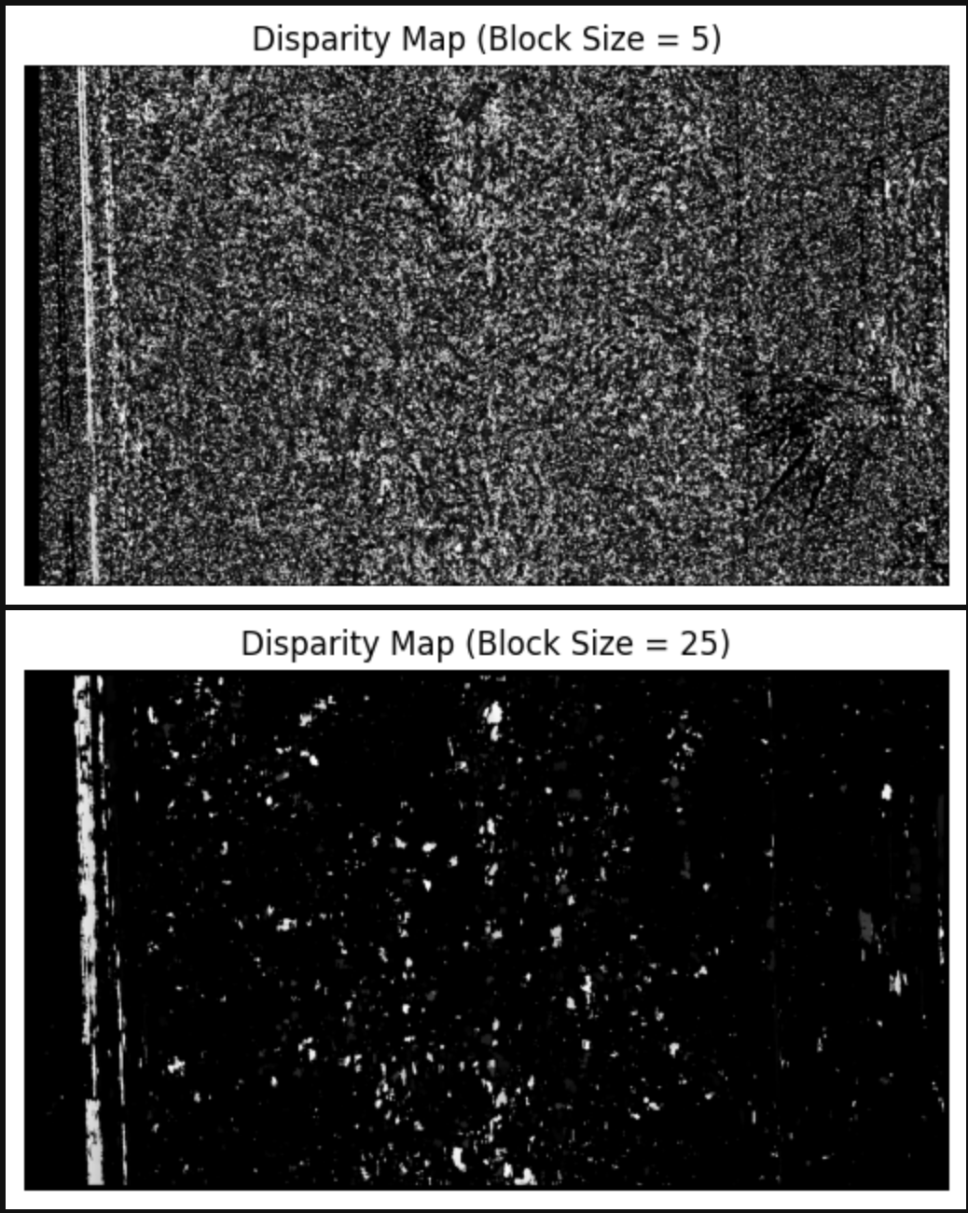

1. Optical Flow Vectors  
   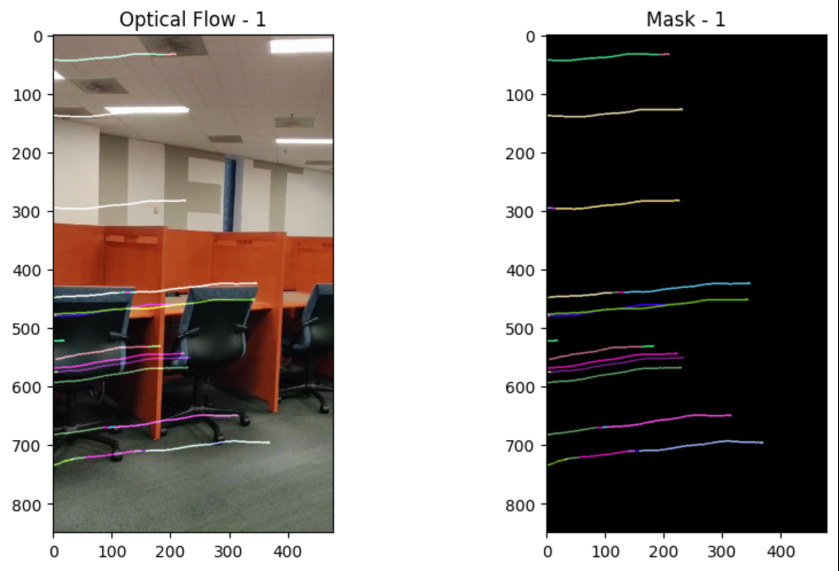

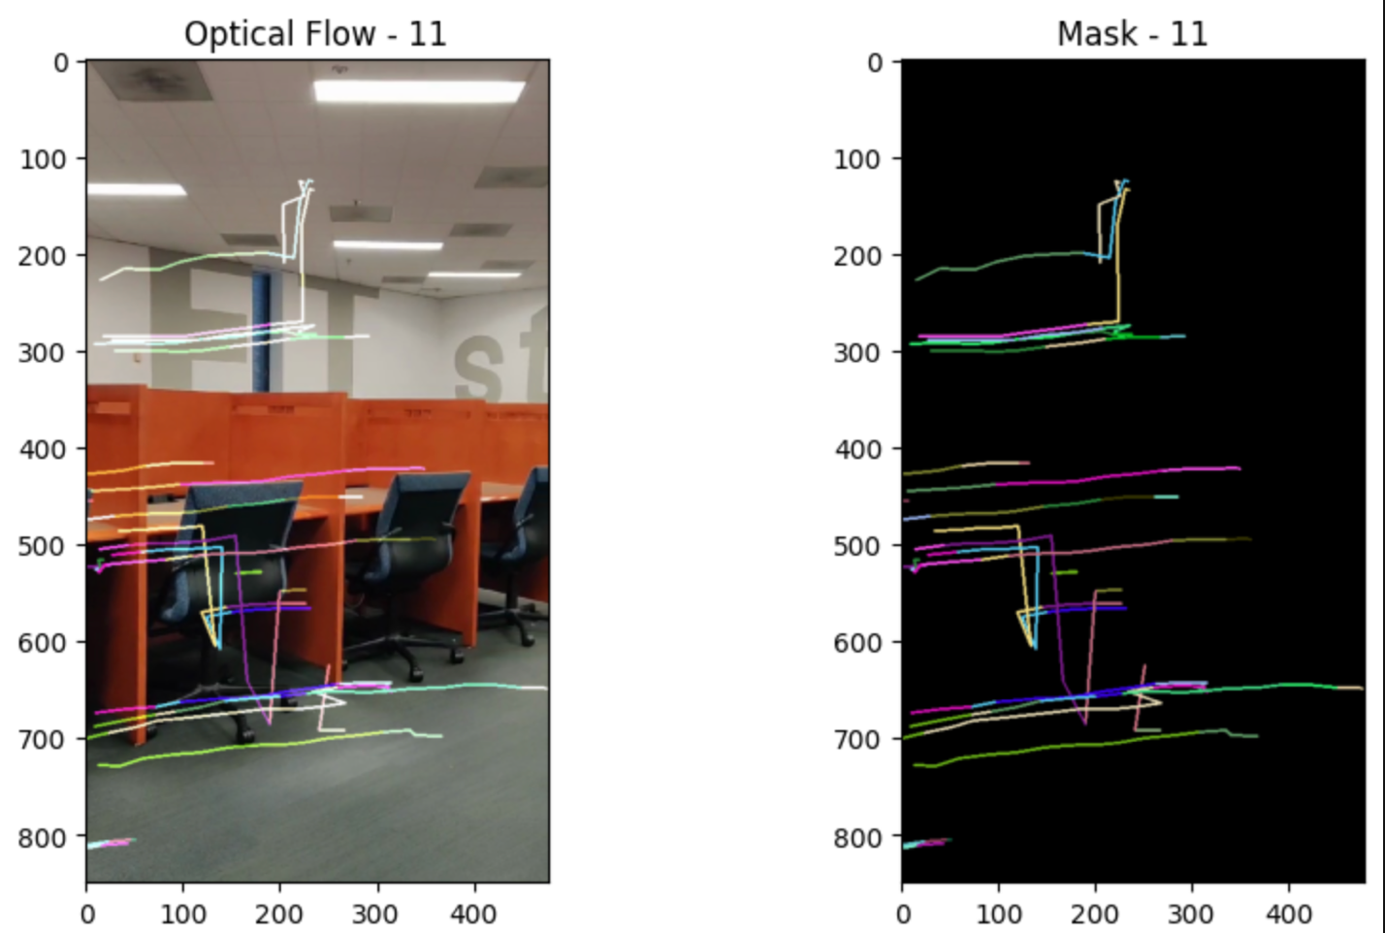

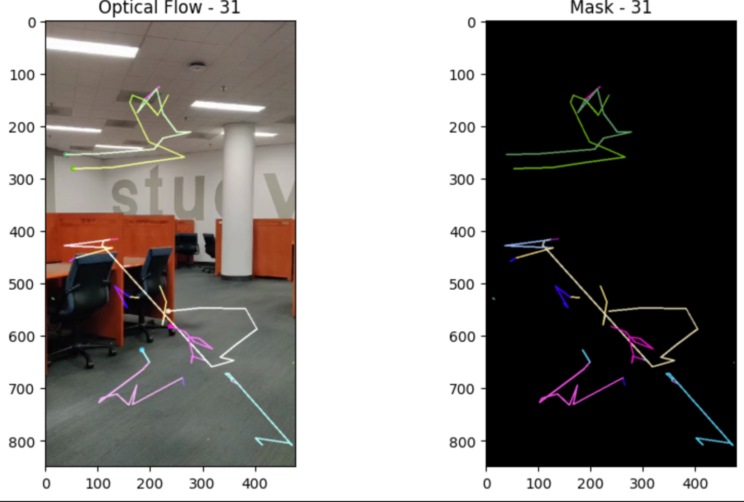

1. Bag Of Features

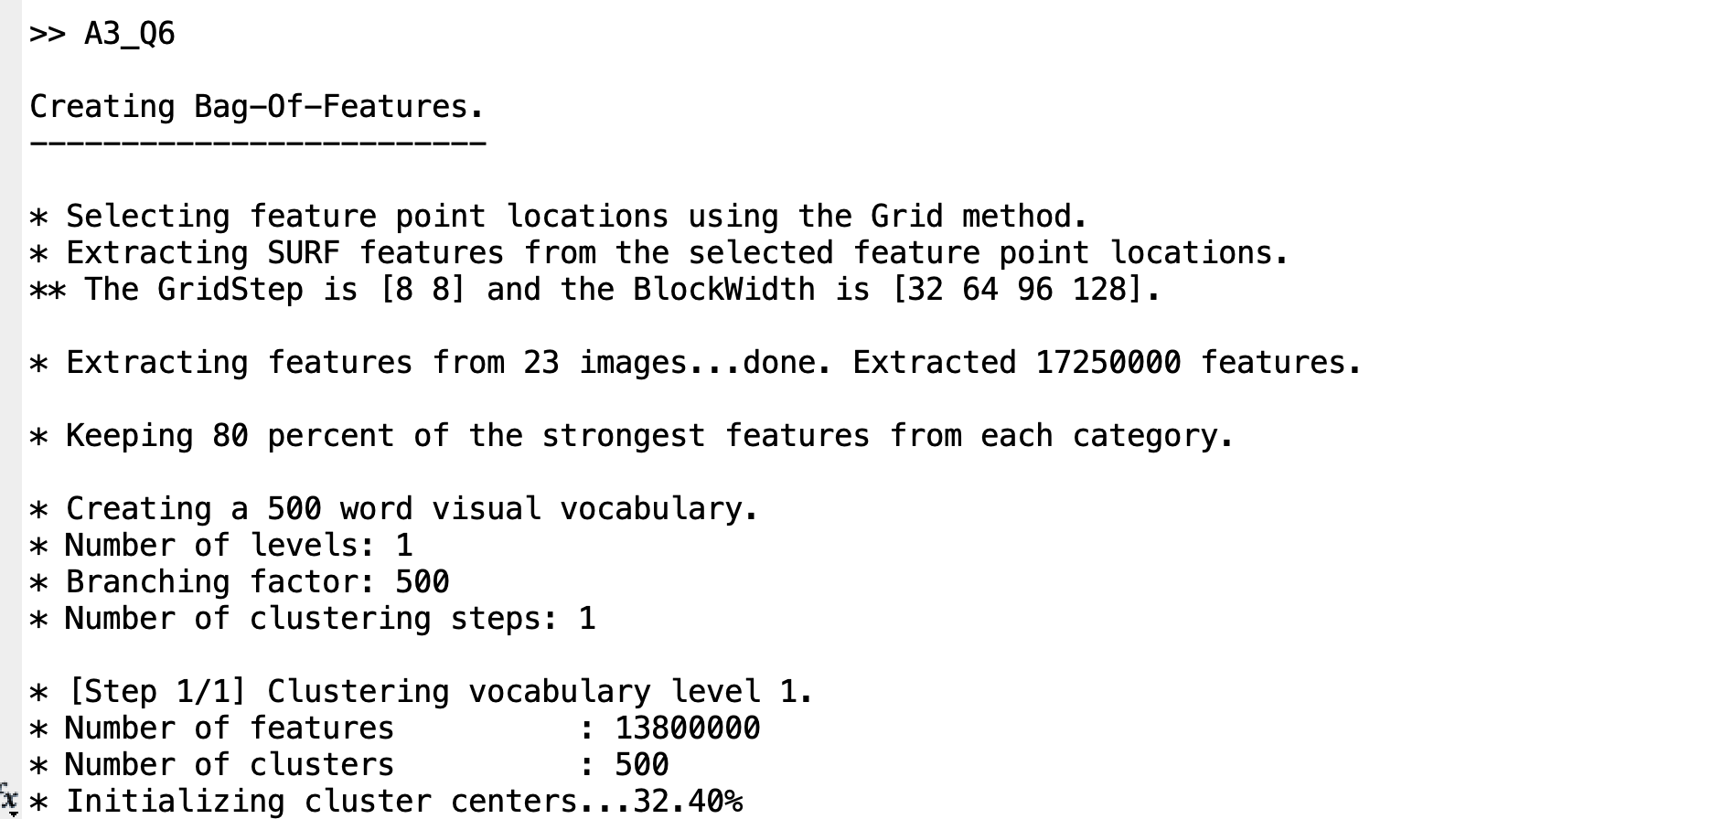

1. Assumptions made:  
     
   **Fundamental Matrix Estimation**: The script estimates the fundamental matrix using RANSAC (Random Sample Consensus) algorithm. It assumes that enough putatively matched points can be found to robustly estimate the fundamental matrix. If the number of matching points is insufficient or if the epipoles are inside the images, the script will terminate with an error.

**Stereo Rectification**: The script estimates stereo rectification transformations based on the fundamental matrix and matched feature points. It assumes that the computed transformations correctly rectify the stereo images, aligning corresponding features along epipolar lines. The accuracy of stereo rectification affects the quality of subsequent depth estimation.

Distance D – 70 cm, T – 12 cm, Rotation – 40 degree  
  
Image Pairs Before Rotation:

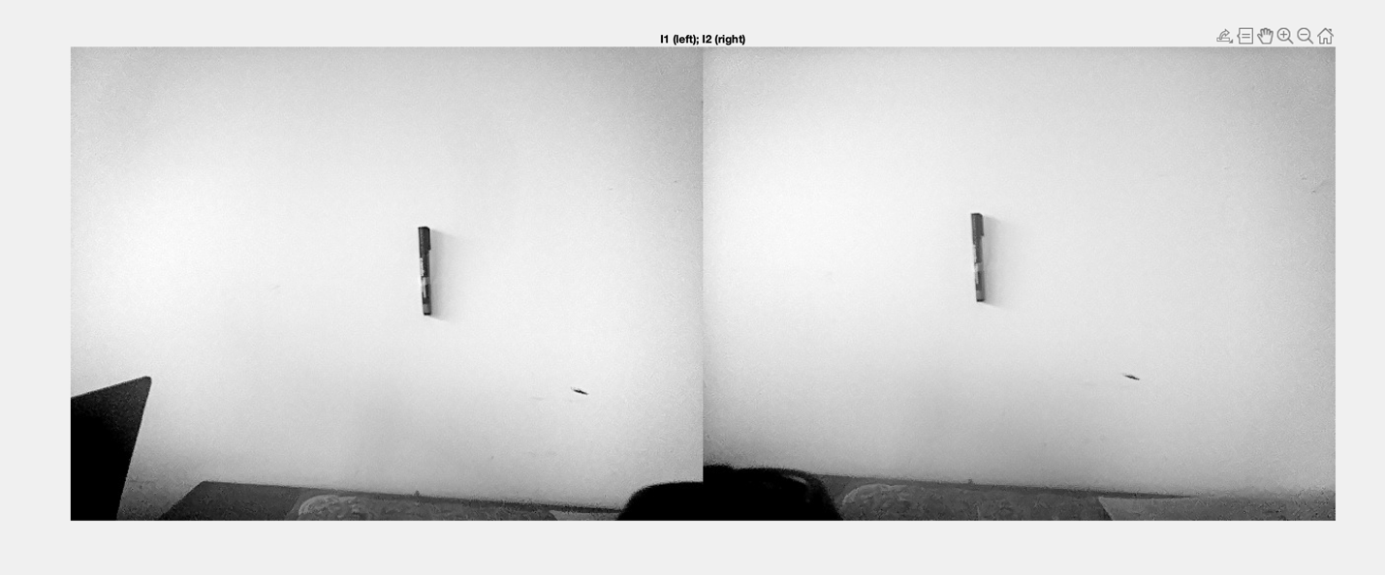

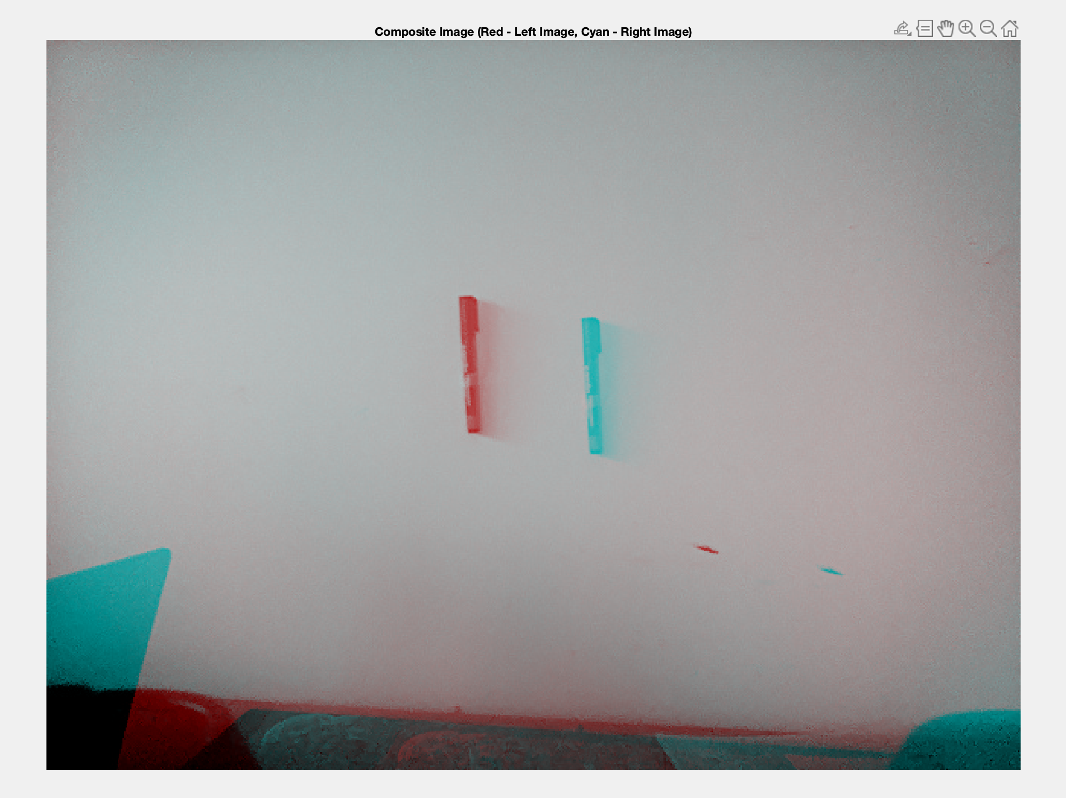

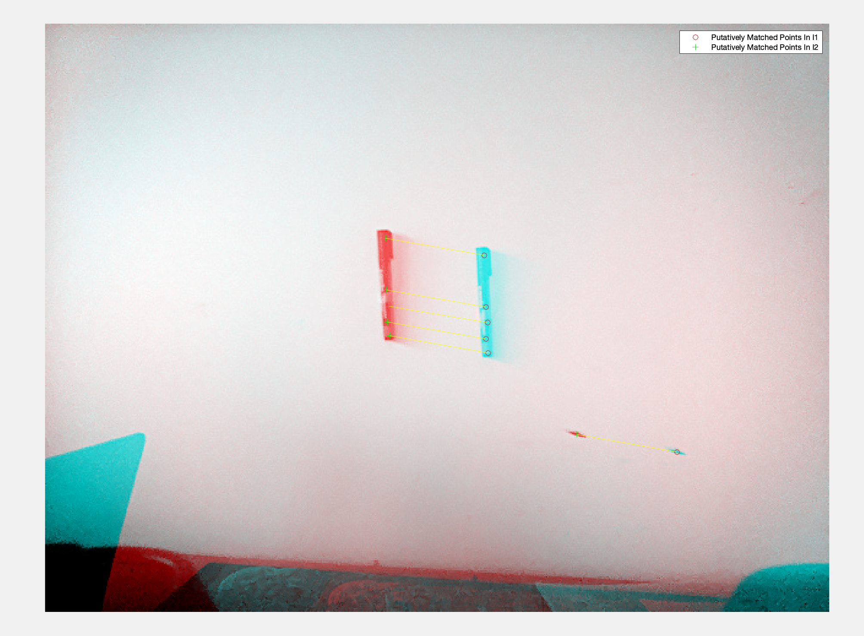

Image Pairs after rotation:  
  
